10th January 2018 – Notice 001/2018

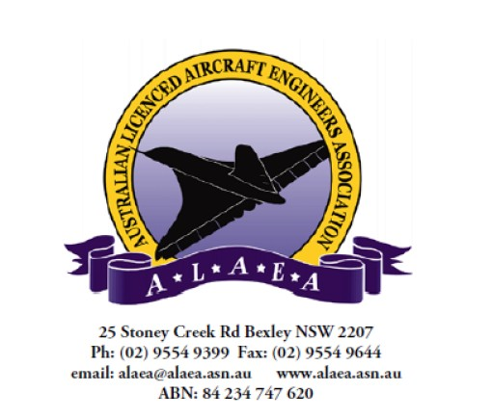

- N O T I C E 

TO: QANTAS LAME MEMBERS

RE: Full results of ALAEA Qantas Member Wage Structure/Training
survey enclosed along with Executive analysis.

Hi all,

Full results of ALAEA Qantas member Wage Structure/Training survey enclosed along with Executive analysis.

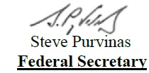

See Attachments

